# [Top Secret Tourism](http://feralhouse.com/press/mini_sites/top_secret_tourism/blog/)

## December 11, 2006

### [**A Top Secret Tour From Las Vegas**](http://feralhouse.com/press/mini_sites/top_secret_tourism/blog/2006/12/a_top_secret_tour_from_las_veg_1.html)

Las Vegas is more than just the epicenter of Western Civilization------it’s also the starting point for a lengthy day trip that includes three major Top Secret America sites.

This trip will take about ten to twelve hours. You should top off your car’s gas tank at every opportunity----at certain points of this trip, you’re literally over 80 miles from the nearest gas station. Your car should be in good working order, and carrying along some snacks and water would be a good idea. While this trip is through desert, that doesn’t mean the weather will always be warm. Much of this trip is at elevations of over a mile, and freezing temperatures (and even snow) are common in the winter months, so warm clothing would be a good idea if you do this trip from November through March. And be sure to observe posted speed limits in any towns you may pass through, such as Beatty and Tonopah. Speeding fines make up a substantial portion of the budget of such small towns.

With those warnings out of the way, let’s get started. From Las Vegas, take Highway 95 north from Interstate 15; this is the road to Mount Charleston. The Las Vegas housing developments eventually end and you’re in the open desert. About 65 miles north of Las Vegas, you reach the “town” of Mercury. If you take the exit off Highway 95 for Mercury, you come to the entrance for the Nevada Test Site (NTS) and can go no further.

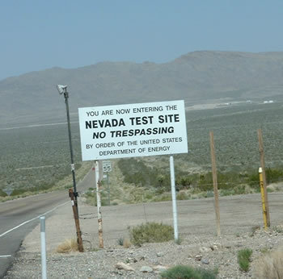

The Nevada Test Site is the most heavily-nuked piece of real estate on the planet. 126 above-ground tests were conducted here along with over 800 underground tests. Testing of actual weapons ended in 1992, but “subcritical” tests involving amounts of fissionable material too small to sustain a chain reaction are still conducted. Today, the NTS conducts open-air tests of toxic materials, disassembles atomic weapons, develops ways to clean up radioactively polluted sites and, according to a 2001 report in the New York Times, also conducts germ warfare experiments.

The NTS is larger than the state of Rhode Island and has 1100 buildings, 400 miles of paved roads, 300 miles of dirt roads, housing for 1200 employees, a hospital, a post office, a fire station, and a Nye County sheriff’s department substation (who are there mainly to arrest trespassers and haul them to the county jail). Surprisingly, the NTS also offers public tours with advance registration; complete details can be found in my book, TOP SECRET TOURISM, published by Feral House.

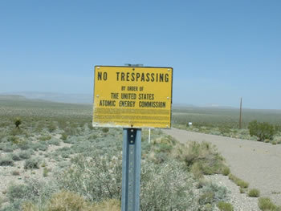

About 10 miles north of the NTS, you might notice some mysterious activity to the west. You’ll see a group of buildings about 5 miles away, and single- and twin-engine aircraft will be seen landing near them. Is this an adjunct facility to the Nevada Test Site? A germ warfare lab? A CIA desert training base? No, it’s actually the “town” of Crystal, NV, the buildings are brothels, and the airplanes are shuttling well-heeled customers from Las Vegas.

Another 50 miles north on Highway 95 is the town of Beatty, where gasoline, food, and lodging are available. Fifty miles north of Beatty is the semi-ghost town of Goldfield. It clings to life as the county seat of Esmeralda County, although it has no gas stations or places to eat.

Tonopah is 30 miles north of Goldfield, and has a shabby, tattered look; many of its downtown buildings and businesses are vacant and appear abandoned. Its economy is based on the boom-and-bust cycles of mining, and mining has been in a “bust” phase for several years. However, Tonopah is the county seat of Nye County, and that keeps the town barely alive. Tonopah has seen some interesting history; Howard Hughes married Jean Peters in Tonopah, and a young Jack Dempsey was the bouncer at the bar of the now-closed Mizpah Hotel.

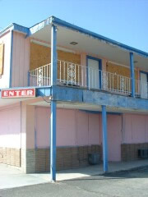

Howard Hughes married Jean Peters in the second floor room immediately to the right of the "Enter" sign. This crumbling structure is typical of many buildings in Tonopah.

Tonopah has another distinction. Starting in the mid-1980s, its citizens became aware that something unusual was going on at the nearby Tonopah Test Range (TTR). New facilities were constructed at the base, including 54 aircraft hangers. At night, strange lights moving silently through the sky were common sights over Tonopah. And some people reported seeing strange black airplanes around dusk and dawn. But the TTR and its personnel injected some badly needed cash into the Tonopah economy, so the citizens of Tonopah kept quiet about what they were seeing.

It turned out that TTR was home to the then-secret F-117 Stealth fighter/bomber. After the F-117 was declassified in 1992, its operations were transferred out of TTR. But Tonopah is proud of its role in the development of Stealth technology; a sculpture outside the local fire department honors Tonopah as the “home of Stealth.”

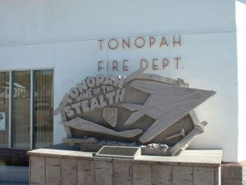

Our next stop is the TTR. Before leaving Tonopah, be sure to top off your gas tank! To reach the TTR, drive east from Tonopah on Highway 6 for about 15 miles and turn right at the TTR sign (it’s shaped like a rocket and can’t be missed). You will then travel approximately twenty miles south to a guardhouse manned 24 hours a day. Caution is required as you approach the guardhouse, as the TTR boundary is before the guardhouse and is poorly marked; it’s easy to stray across the boundary if you’re not careful. The boundary area is highly developed, and you can see numerous aircraft hangers, housing, and support buildings. The “barracks” are hotel-like and far superior to housing found on other military bases. They included soundproofing and “blackout” curtains since almost Stealth operations were conducted at night and personnel slept during the day. While TTR went into a “caretaker” status after the F-117 was declassified in 1992, there has recently been a flurry of activity, including new buildings and roads being repaved, and security has been increased. If there are any new secret aircraft now operational, odds are they are operating out of TTR.

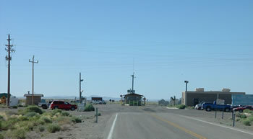

Entrance gate to the Tonopah Test Range; note how the actual boundary extends out from the guardhouse.

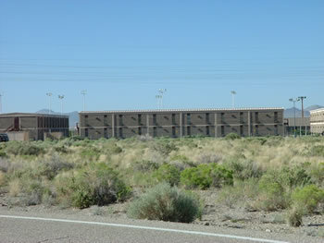

Housing barracks at TTR,

The final stop on our trip is the big one, namely the legendary Area 51. Return to Highway 6 and drive east for about 30 miles to the intersection with Highway 375 (now named “the Extraterrestrial Highway”). Highway 375 is an “open range” highway, meaning it is common to see cattle wandering around in the middle of the road. You’ll drive 60 miles south on Highway 375 to the ground zero of the Area 51 phenomenon, the small town of Rachel. For most of this trip, you'll be out of range of cell phone service and reception of terrestrial radio stations will be poor. The sense of isolation can be overwhelming.

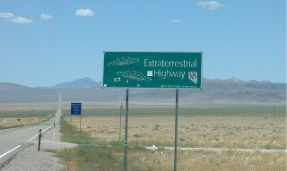

The State of Nevada got into the Area 51 craze when it christened Highway 375 "the Extraterrestrial Highway."

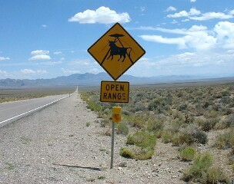

Even the warning signs about open range cattle grazing on Highway 375 have a UFO theme.

The town of Rachel is little more than a collection of trailers in the high desert; the permanent population hovers around 100. The main attraction in Rachel is the Little A’le’Inn. The Little A’le’Inn caters to those who come to Area 51 looking for UFOs; its walls are plastered with UFO photos and posters and it carries an extensive selection of UFO merchandise for sale. It also has a restaurant and operates the “Dreamland Resort,” a spartan motel cobbled together from trailers that provides the only accommodations in Rachel (other than camping in the open desert). The Little A’Le’Inn now has a melancholy air compared to its heyday in the 1990s; one of its co-owners died in 2003 and it now gets only a fraction of the visitors/customers it once did. While the UFO fanatics seem to be losing interest, Area 51 and Rachel still draw visitors trying to glimpse still-secret aircraft undergoing development and testing.

The so-called “Main Gate” is the most visited place on the Area 51 boundary. It is located off Highway 375 approximately 24.5 miles south of Rachel; the access road is an unmistakable long, straight gravel road leading to the west. Satellite photos indicate this road continues through Area 51 into the Nevada Test Site and eventually to Highway 95. This distance to the Area 51 border is just short of 14 miles. As you approach the border, the terrain will get hilly and you may see the glint of reflected sunlight from security vehicles. Slow down after having traveled 13 miles, as the Area 51 boundary is not blocked by a security gate and the guardhouse is not visible from outside Area 51-----it is around a bend in the road approximately a half-mile past the boundary. The actual border is well-marked by numerous warning signs, and you must not pass beyond the warnings signs under any circumstances! If you do, you will be detained by Area 51’s legendary security forced known as the “Cammo Dudes” and turned over to the Lincoln County sheriff’s department for arrest. Stop short of the border, turn around, and park well over to the side of the road so as not to block traffic.

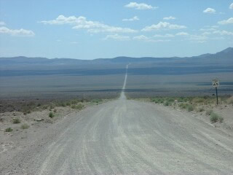

The road to the Area 51 main gate is both long and arrow-straight!

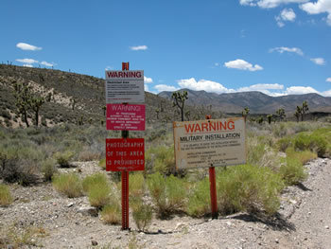

These signs are no joke-----you will be arrested if you go past them, and the Area 51 guards are authorized to use deadly force against intruders. Be like me, and be content with photographing a "No Photography Allowed" sign.

You will be under video and human surveillance at the main gate. The Cammo Dudes (so named because of their uniforms) and their trucks (or SUVs) will be visible from the main gate. If you check them out with binoculars, you will see they are also checking you out with binoculars or a video camera. Other than the signs and Cammo Dudes, there’s not much to see from the main gate. But it’s fun to be next to a facility that, officially, doesn’t even exist.

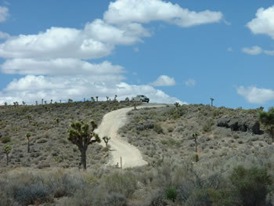

An Area 51 "Cammo Dude" stands guard just inside the Area 51 border.

To return to Las Vegas, return to Highway 375 and take it south until it intersects with Highway 93, then follow Highway 93 south to its intersection with Interstate 15.

Posted by [Harry Helms](http://topsecrettourism.com) on December 11, 2006 5:05 PM | [Permalink](http://feralhouse.com/press/mini_sites/top_secret_tourism/blog/2006/12/a_top_secret_tour_from_las_veg_1.html) | [Comments (0)](http://feralhouse.com/press/mini_sites/top_secret_tourism/blog/2006/12/a_top_secret_tour_from_las_veg_1.html#comments) | [TrackBacks (0)](http://feralhouse.com/press/mini_sites/top_secret_tourism/blog/2006/12/a_top_secret_tour_from_las_veg_1.html#trackback)